**Microscopes**

**Aim**

To accurately measure small objects with a microscope.

**Materials**

* light microscope
* 4 concave microscope slides
* variety of small seeds
* small beaker or cupcake liners
* tweezers
* flat, transparent metric ruler

**Part 1: Measuring the field of view.**

**Method**

1. Set up the microscope with the lowest power objective lens. Calculate the total magnification and enter it into the first row of the results table below.
2. Place the ruler on the stage and focus the microscope on the ruler markings.
3. Line up the ruler so that it crosses the full diameter of the field of view, as shown in the diagram. Check that the left-hand marking is on the edge of the field of view.
4. Starting from the left-hand marking (zero), count the markings on the ruler. This is the diameter. Record the measurement (in mm) in the results table.  
   (*Note: If you can, use decimals to improve accuracy. e.g. 3.2 mm if there is an extra 0.2 mm in view*)
5. Repeat Steps 1–4 using the other objective lenses.
6. Convert the measurements to µm and complete the results table.

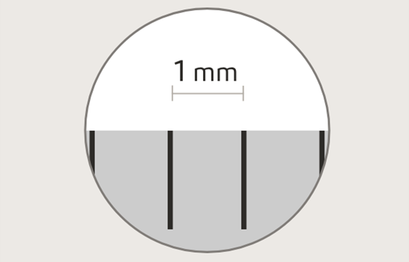Line up the ruler across the diameter of the field of view. Notice how the left-hand marking is right on the edge of the field of view.

**Important note:**

At higher magnifications, the millimetre markings may be too far apart to appear together in the field of view. If this happens, use the measurement from a lower magnification to make an estimate.

For example, you can estimate the field of view diameter at 400x magnification using the measured diameter at 100x. The magnification is 4 times greater so the field of view will be 4 times *smaller*. This means you need to *divide* by 4.

**Results**

|  |  |  |
| --- | --- | --- |
| **Total magnification**  (ocular magnification x objective magnification) | **Field of view**  **diameter (mm)** | **Field of view**  **diameter (µm)** |
|  |  |  |
|  |  |  |
|  |  |  |

**Part 2: Calculating the sizes of specimens.**

**Method**

**Counting the number of specimens that fit in the field of view.**

1. Use the lowest power objective lens to focus on one poppy seed.
2. If appropriate, select a higher-powered objective lens. If the seed takes up the whole field of view after zooming in, zoom back out until the whole seed is in view.
3. Estimate the number of seeds that would fit across the diameter by imagining a row of them (right). Record this number and the total magnification in the results table below.
4. Repeat Steps 1–3 for the other types of seeds.

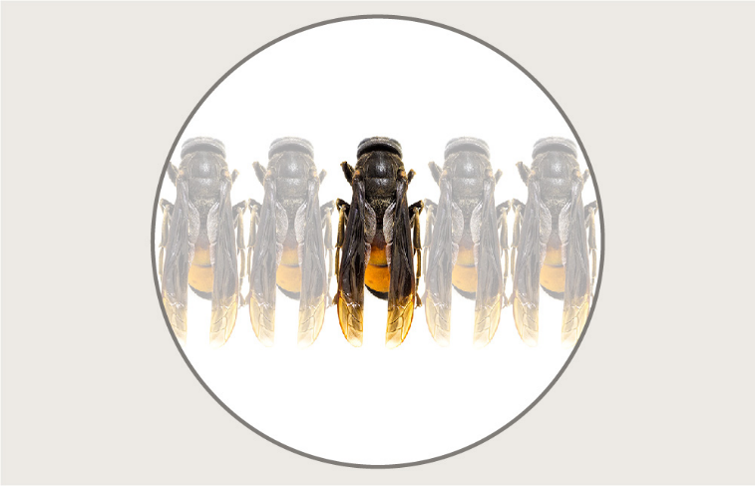

Five flies would fit across this field of view.



|  |  |  |  |  |
| --- | --- | --- | --- | --- |
| **Specimen** | **Number of specimens that fit in field of view** | **Total magnification** | **Field of view diameter (µm)** | **Length of specimen (µm)** |
|  |  |  |  |  |
|  |  |  |  |  |
|  |  |  |  |  |
|  |  |  |  |  |